**MINAHIL QADIR**

**BSAI-3A(047)**

**TASK 8:**

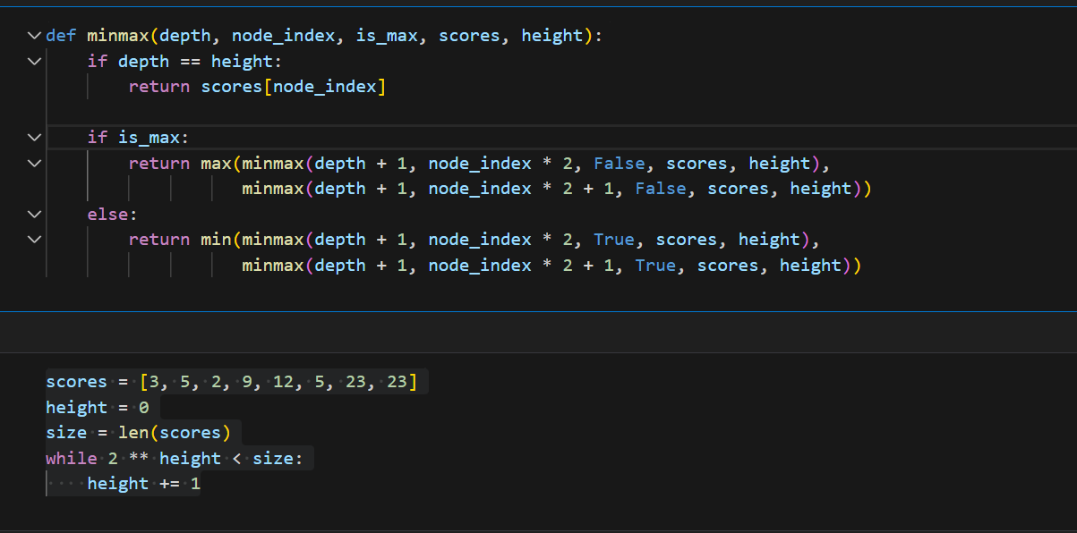 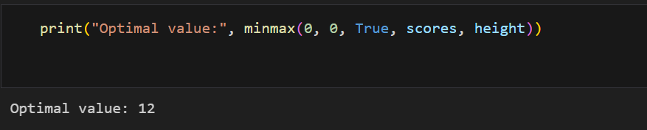

This program finds the best move using the Minimax algorithm, which is used in games.

It goes through a game tree, where:

The max player picks the highest score.

The min player picks the lowest score.

It keeps checking options until it reaches the given scores.

It calculates the tree height based on the number of scores.

Finally, it finds the best possible score to play.